## “RFID Based Smart School”

## A

**PROJECT REPORT**

Submitted in partial fulfillment of the requirement for the award of the Degree of

## BACHELOR OF ENGINEERING

**In**

**Electronics & Telecommunication**

**By**

1. **Abhishek R. Pawar (72142248K)**
2. **Sayali A. Sawant (72142274J)**
3. **Prerana D. Mane Deshmukh (72142223D)**

**Under the Guidance of K.G.Jagtap**



### DEPARTMENT OF ELECTRONICS AND TELECOMMUNICATION SHIVNAGAR VIDYA PRASARAK MANDAL

**College of Engineering Malegaon (BK) - 413 115 Of**

**SAVITRIBAI PHULE PUNE UNIVERSITY 2023-2024**



***CERTIFICATE***

This is to certify that

1. **Abhishek R. Pawar 72142248K**

**2 Sayali A. Sawant 72142274J**

**3 Prerana D. Mane Deshmukh 72142223D**

have satisfactorily submitted the Seminar report titled

## “RFID Based Smart School”

in partial fulfilment of Bachelor of Engineering in

## Electronics & Telecommunication

### At

**College of Engineering, Malegaon (Bk)**

**SAVITRIBAI PHULE PUNE UNIVERSITY (2023-24)**

|  |  |  |
| --- | --- | --- |
| **Prof. K.G. Jagtap** | **Dr.Y.V.Parkale** | **Dr.S.M.Mukane** |
| **Internal Guide** | **H.O.D.** | **Principal** |

**ACKNOWLEDGMENT**

It is my proud privilege and duty to acknowledge the kind of help and guidance received from several people in preparation of this report .It would not have been possible to prepare this report in this form without their valuable help cooperation and guidance.

First and foremost I wish to record my sincere gratitude to our beloved Principal **Dr.S.M.Mukane** for his constant support and encouragement in preparation of this report and for making available library and laboratory facilities needed to prepare this report.

I express my sincere gratitude to my guide **K.G.Jagtap** , for guiding me in investigations for this project and in carrying out experimental work.

My sincere thanks to **Dr.Y.V.Parkale** Head of Department of Electronics and Telecommunication Engineering, for his valuable suggestions and guidance throughout the period of this report.

Finally, I would like to wish special thanks to Management of SVPM’s College of Engineering, Malegaon (Bk.), all staff members, my family members and friends, without whose patience, encouragement, and support this Project work might never have been completed.

**Abhishek R. Pawar**

**Sayali A. Sawant Prerana D. Mane Deshmukh**

Table of contents

|  |  |  |
| --- | --- | --- |
| **Chapter** | **Topic** | **Page Number** |
| 1. | Introduction | 5 |
| 2. | Literature Survey | 7 |
| 3. | Problem Statement | 9 |
| 4. | Proposed system | 10 |
| 5. | Block Diagram & Description | 12 |
| 6. | Design & selection of components | 15 |
| 7. | Circuit Diagram | 21 |
| 8. | Algorithm & Flow Chart | 23 |
| 9. | Results | 29 |
| 10. | Advantages | 31 |
| 11. | Application | 33 |
| 12. | Conclusion | 35 |
| 13. | Future Scope | 36 |
| 14. | References | 38 |

**Introduction**

In an era where technological advancements are revolutionizing various aspects of our lives, the integration of smart systems in public transportation is becoming increasingly prevalent. This project represents a paradigm shift in how we monitor and manage entries and exits on buses, leveraging the capabilities of the ESP8266 microcontroller, RFID (Radio Frequency Identification) technology, and the Telegram messaging platform.

The fusion of these technologies culminates in a sophisticated system capable of real-time tracking and notification of passengers boarding and alighting from buses. By harnessing the power of wireless communication and secure data transmission, this project addresses the need for efficient and seamless monitoring in public transportation systems.

The foundation of this project lies in the ESP8266 microcontroller, renowned for its versatility and connectivity capabilities. As the backbone of the system, the ESP8266 facilitates the connection to a local WiFi network, enabling seamless communication with external platforms such as Telegram. Moreover, its compact form factor and low power consumption make it an ideal choice for embedded applications, ensuring the system remains robust and energy-efficient.

Complementing the ESP8266 is the RFID module, a key component responsible for identifying passengers as they interact with the system. RFID technology, based on radio frequency communication, offers a non-contact method of authentication, making it ideal for applications where convenience and efficiency are paramount. By assigning unique identifiers to RFID cards carried by passengers, the system can accurately track their movements without the need for physical interaction.

Central to the functionality of the system is the Telegram bot, a versatile platform for instant messaging and communication. Leveraging the Telegram API, the system can send and receive messages in real-time, enabling seamless interaction with users. By integrating the bot into the system, passengers receive timely notifications regarding their boarding and alighting status, enhancing their overall experience and providing valuable insights into bus occupancy.

The workflow of the system is straightforward yet highly effective. Upon initialization, the ESP8266 establishes a secure connection to a designated WiFi network, ensuring reliable communication throughout the operation. Simultaneously, the RFID module is configured to detect and read RFID cards presented by passengers, extracting their unique identifiers for further processing.

In the main loop of the system, the ESP8266 continuously monitors the RFID module for new card detections. Upon detecting a card, the system retrieves its unique identifier and determines the corresponding passenger's action based on the state of a predefined pin. If the pin indicates an entry, the system notifies the Telegram bot of the passenger's boarding, providing pertinent details such as their name and timestamp. Conversely, if the pin indicates an exit, a similar notification is sent to the bot, signaling the passenger's departure from the bus.

Throughout this process, the Telegram bot serves as the conduit for communication, relaying notifications to a predefined chat ID in real-time. Whether it's informing passengers of their boarding status or providing administrators with insights into bus occupancy, the bot ensures that stakeholders remain informed and empowered to make data-driven decisions.

In summary, this project represents a convergence of cutting-edge technologies aimed at revolutionizing how we monitor and manage entries and exits on buses. By leveraging the ESP8266 microcontroller, RFID technology, and the Telegram messaging platform, the system offers a seamless and efficient solution for real-time tracking and notification in public transportation systems. As society continues to embrace smart technologies, projects like these serve as a testament to the limitless possibilities of innovation in the realm of transportation.

Top of Form

**Literature Review**

**T.S. Lim, Et al. -** Student irregular attendance is a pressing concern for educational institutions, as it can significantly impact academic performance. Conventional methods of attendance-taking, such as calling out names or manual sign-ins, are not only time-consuming but also prone to inaccuracies and security risks. In response to this challenge, Radio Frequency Identification (RFID) based attendance systems offer a compelling solution. RFID technology allows for the unique identification of individuals through RFID-tagged ID cards, making the attendance-taking process more efficient, accurate, and secure. This system can be implemented in schools, colleges, universities, and workplaces alike, providing a universal solution for attendance management. With RFID-based attendance systems, students or workers simply need to place their ID card on a reader, and their attendance is instantly recorded. The real-time clock capability ensures precise time recording, enhancing the accuracy of attendance data. Furthermore, the system can be seamlessly integrated with computers via RS232 or Universal Serial Bus (USB) ports, allowing attendance records to be stored directly in a database for easy access and management. Alternatively, attendance data can be viewed using HyperTerminal software, providing administrators with convenient access to recorded attendance. Overall, the development of a prototype for this RFID-based attendance system marks a significant advancement in attendance management practices, offering educational institutions and workplaces a reliable, efficient, and secure solution for tracking attendance.[1]

**Ononiwu G. Chiagozie, Et al. -** Radio-frequency identification (RFID) technology utilizes radio waves to transfer data from an electronic tag, known as an RFID tag or label, attached to an object, to a reader for the purpose of identification and tracking. Widely adopted across various industries for automation purposes, RFID technology serves as the foundation for numerous organizational systems. This study focuses on the development of an RFID-based time-attendance management system. Comprising both hardware and software components, the system is designed to streamline attendance tracking processes. The hardware setup includes a motor unit and an RFID reader operating at a frequency of 125 kHz, connected to a host computer via a serial to USB converter cable. The software component of the system consists of a graphical user interface (GUI) developed using visual basic.Net. This GUI, referred to as the Time-Attendance Management System, serves as the central interface for the overall system. It offers functionalities such as displaying live ID tag transactions, registering and deleting IDs, recording attendance, and handling other minor tasks. The interface is installed on the host computer, providing users with a user-friendly platform for managing attendance data efficiently.Top of Form

[2]

**Murizah Kassim, Et at. -** This paper presents the development of a student attendance system utilizing Radio Frequency Identification (RFID) technology. Traditional attendance systems rely on manual signing of attendance sheets by students during class sessions. While commonplace, such methods lack automation, leading to various issues such as time wastage as students search for and sign their names, potential for erroneous or deliberate signing on behalf of others, and the risk of attendance sheets being misplaced. The primary objective of our system is to address these challenges by automatically capturing student attendance through RFID card scanning at dedicated readers. By implementing such a system, we aim to eliminate the aforementioned issues and provide lecturers with an online platform accessible anytime and anywhere, facilitating seamless attendance monitoring. On a broader scale, deploying this system across academic faculties offers numerous benefits to academic management. Improved attendance tracking contributes to enhanced teaching quality and better student performance monitoring. Additionally, the system offers valuable online features for easy record maintenance, benefiting lecturers and academic management staff alike in efficiently monitoring students' progress.[3]

**Hasan U. Zaman, Et al. –** RFID technology functions as an automated wireless identification system, utilizing both active and passive cards alongside a reader. This study aims to alleviate the challenges associated with manual attendance tracking through the adoption of RFID technology. By implementing this system, the management of attendance records becomes more organized, efficient, and time-saving.

The proposed method has been successfully realized in a prototype system, demonstrating the effectiveness of RFID technology in automating attendance management tasks. The system's automation streamlines the attendance-taking process, resulting in improved efficiency and accuracy. The design of the system is characterized by its simplicity, affordability, and portability, making it suitable for both commercial and academic use. This system presents a viable solution for addressing attendance management challenges in various contexts.

**Problem Statement**

In today's fast-paced world, efficient management and monitoring of public transportation systems have become paramount. However, traditional methods of tracking passenger entries and exits on buses often lack real-time insights and can be labor-intensive. Manual ticketing systems are prone to errors and do not provide instant feedback to passengers or administrators. Additionally, accurately assessing bus occupancy in real-time is a challenge, leading to inefficiencies in resource allocation and scheduling.

To address these challenges, there is a need for a smart and automated system that can seamlessly monitor passenger movements on buses in real-time. Such a system should provide instant notifications to passengers regarding their boarding and alighting status while also enabling administrators to track bus occupancy and optimize routes accordingly.

The existing solutions for bus monitoring often rely on manual ticketing systems or rudimentary RFID-based solutions that lack integration with modern communication platforms. These systems are limited in their ability to provide real-time updates and require significant human intervention for data collection and analysis.

Therefore, the problem statement is to design and develop an integrated system that combines an ESP8266 microcontroller, an RFID module, and a Telegram bot to create a robust solution for monitoring entries and exits on buses. This system should offer:

1. Real-time tracking of passenger entries and exits on buses.
2. Instant notifications to passengers regarding their boarding and alighting status.
3. Seamless integration with a secure communication platform like Telegram for notifications.
4. Accurate assessment of bus occupancy to facilitate route optimization and resource allocation.
5. Automation of monitoring processes to minimize human intervention and errors.

By addressing these requirements, the proposed system aims to revolutionize the way public transportation systems are monitored and managed, enhancing passenger experience and operational efficiency.

**Proposed System**

The proposed system aims to revolutionize the monitoring and management of entries and exits on buses and school by leveraging the integration of an ESP8266 microcontroller, an RFID module, a Telegram bot and Google sheet. The system will provide real-time tracking of passenger movements, instant notifications to passengers regarding their boarding and alighting status, and seamless communication with administrators for efficient bus management.

**Key Components:**

1. **ESP8266 Microcontroller:** The ESP8266 will serve as the core of the system, facilitating connectivity to a WiFi network and serving as the interface between the RFID module, Telegram bot, and external communication channels.
2. **RFID Module:** The RFID module will be used to identify and authenticate passengers as they board and alight from buses. Each passenger will carry an RFID card containing a unique identifier (UID), which will be read by the RFID module upon presentation.
3. **Telegram Bot:** The Telegram bot will enable seamless communication between the system and passengers/administrators. It will send and receive messages in real-time, providing notifications to passengers regarding their boarding and alighting status, as well as facilitating communication with administrators for monitoring and management purposes.
4. **Google Sheet Integration**: The ESP8266 microcontroller communicates with Google Sheets specifically to log student entries and exits within the school.

**Functionality:**

1. **Initialization:** The ESP8266 will establish a secure connection to a designated WiFi network and set up communication with the Telegram bot.
2. **RFID Setup:** The RFID module will be initialized, specifying the pins used for communication with the ESP8266.
3. **Main Loop:** The system will continuously monitor for new RFID cards. Upon detecting a new card, it will read its unique identifier (UID) and determine the associated passenger's action based on the state of a predefined pin (e.g., pin D2). If the pin indicates an entry, the system will notify the Telegram bot of the passenger's boarding. If the pin indicates an exit, a similar notification will be sent to the bot, indicating the passenger's departure from the bus.
4. **Telegram Notifications:** The Telegram bot will send messages to a specified chat ID, informing passengers of their boarding and alighting status. Notifications will include details such as the passenger's name and the timestamp of the event.
5. **Student Tracking:** When students enter or exit the school premises, they tap their RFID card/tag on the reader. The RFID module then sends this information to the ESP8266 microcontroller.
6. **Data Logging to Google Sheets:** The ESP8266 microcontroller updates a designated Google Sheets spreadsheet in real-time with each student's entry and exit information. This includes their unique identification, timestamp, and whether it's an entry or exit.
7. **Administrative Monitoring:** School administrators have access to the Google Sheets spreadsheet, allowing them to monitor student movements and attendance in real-time.

Overall, the proposed system will provide a seamless and efficient solution for monitoring entries and exits on buses, enhancing passenger experience and enabling administrators to make informed decisions regarding bus management and optimization.

**Block Diagram and Description**

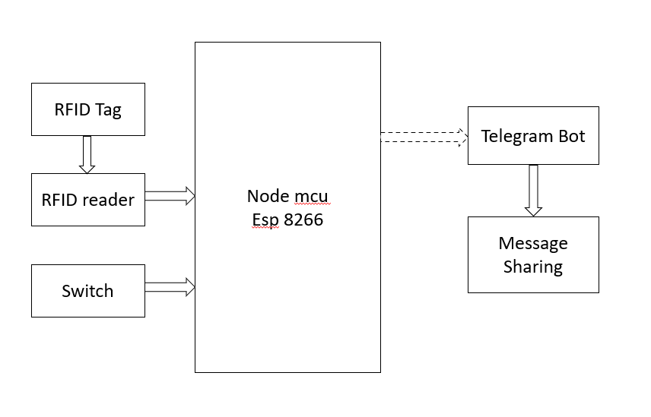

Fig 5.1 – Block Diagram (at bus)

The provided block diagram illustrates the architecture of a system that combines an ESP8266 microcontroller with an RFID module and a Telegram bot for monitoring entries and exits on a bus.

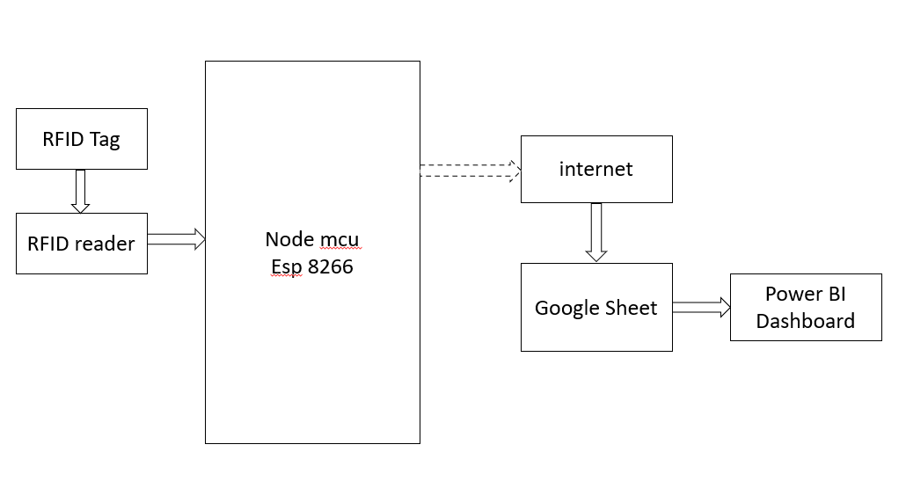

Fig 5.1 – Block Diagram (at school)

The provided block diagram illustrates the architecture of a system that combines an ESP8266 microcontroller with an RFID module and a Google sheet for monitoring entries and exits on a school. Let's delve into a detailed description of each component and their interactions.

1. **ESP8266 Microcontroller:** The ESP8266 microcontroller serves as the central processing unit of the system. It is responsible for managing communication between the WiFi module, RFID module, and Telegram bot. Equipped with built-in WiFi capabilities, the ESP8266 connects to a local WiFi network, enabling seamless data transmission and communication with external devices.
2. **WiFi Module:** The WiFi module, integrated into the ESP8266 microcontroller, facilitates wireless communication with the local WiFi network. It allows the microcontroller to establish a stable connection for transmitting and receiving data, enabling remote monitoring and control of the system.
3. **RFID Module:** The RFID module interfaces with the ESP8266 microcontroller to enable RFID card detection and data retrieval. It consists of an RFID reader capable of detecting RFID cards within its vicinity. When a card is detected, the RFID module communicates the unique identifier (UID) of the card to the microcontroller, which processes this information to determine entry or exit events.
4. **Telegram Bot:** The Telegram bot serves as a communication interface between the system and a specified chat ID. It enables the system to send real-time notifications and updates regarding entry and exit events on the bus. The bot is programmed to receive commands and messages from the microcontroller and respond accordingly, facilitating remote monitoring and management of the system.
5. **Main Loop:** The main loop represents the core logic and functionality of the system implemented within the ESP8266 microcontroller. It continuously monitors the status of the RFID module, detecting new RFID cards and processing their UID data. Based on the state of a specified pin (D2), indicating entry or exit, the main loop triggers the Telegram bot to send appropriate notifications to the designated chat ID.
6. **Telegram Bot Notifications:** This component represents the outgoing notifications sent by the Telegram bot to the specified chat ID. These notifications provide real-time updates on entry and exit events occurring on the bus, enabling remote tracking and monitoring of attendance.
7. **Google Sheets**: -Google Sheets is a cloud-based spreadsheet program offered by Google as part of its Google Drive service. It allows users to create, edit, and collaborate on spreadsheets online, without the need for software installation.
8. **Power Bi dashboard**: Power BI is a data analysis and visualization tool that can be used to create reports and dashboards from a variety of data sources. It can be used to track student attendance, but it would likely require the attendance data to be exported from the school information system and imported into Power BI first. In Power BI, you could create a report that shows the number of students present by class, date, or other criteria. You could also create charts and graphs to visualize the data. For example, you could create a pie chart that shows the percentage of students present in each class.

Overall, the system architecture facilitates seamless integration and operation of the ESP8266 microcontroller, RFID module, and Telegram bot to achieve real-time monitoring of entries and exits on the bus. Through wireless communication and automated processes, the system enhances efficiency, accuracy, and convenience in attendance management.

**Component Selection**

**ESP8266: -**  
The ESP8266 is a low-cost Wi-Fi microchip with full TCP/IP stack and microcontroller capability produced by Espressif Systems. It allows microcontrollers to connect to a Wi-Fi network and make simple connections to the internet.

Key features of the ESP8266 include:

1. **Wi-Fi Connectivity**: It supports IEEE 802.11 b/g/n Wi-Fi standards, enabling easy integration with existing Wi-Fi networks.
2. **Microcontroller Capabilities**: The ESP8266 includes a powerful 32-bit microcontroller unit (MCU) based on the Tensilica Xtensa LX106 architecture, which can be programmed using the Arduino IDE or other development platforms.
3. **Low Cost**: One of the most significant advantages of the ESP8266 is its low cost, making it an attractive option for IoT (Internet of Things) projects and DIY enthusiasts.
4. **GPIO Pins**: It features a number of General-Purpose Input/output (GPIO) pins, allowing it to interface with various sensors, actuators, and other peripheral devices.
5. **Flash Memory**: The ESP8266 typically comes with onboard flash memory for storing firmware, code, and data.
6. **Community Support**: Due to its popularity and affordability, the ESP8266 has a large and active community of developers, which means there are plenty of resources, tutorials, and libraries available for development.
7. **Variants**: Over time, Espressif has released several variants of the ESP8266 with different features and capabilities, such as the ESP8266-01, ESP8266-12E, ESP8266-12F, and more.

The ESP8266 has been widely used in various IoT applications, including home automation, smart appliances, weather stations, and more. Its affordability and ease of use have made it a popular choice among hobbyists and professional developers alike.

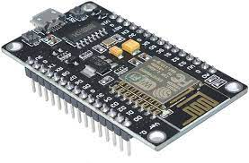

Fig 6.1 – Node MCU ESP8266

**Led : -**

A red LED (Light Emitting Diode) emits red light when a current pass through it in the forward direction. LEDs are semiconductor devices that convert electrical energy into light energy. Here are some key points about red LEDs:

1. **Colour Emission**: Red LEDs emit light in the red portion of the visible spectrum, typically with a wavelength range of around 620 to 750 nanometers (nm). This wavelength range corresponds to the colour red as perceived by the human eye.
2. **Forward Voltage**: Red LEDs typically have a forward voltage drop of around 1.8 to 2.2 volts (V) when operating at standard current levels. This voltage is required to turn on the LED and allow current to flow through it in the forward direction.
3. **Brightness**: The brightness of a red LED can vary depending on factors such as the forward current passing through it and the design of the LED itself. Higher forward currents generally result in higher brightness, but it's essential to stay within the LED's maximum rated current to prevent damage.
4. **Applications**: Red LEDs are commonly used in a wide range of applications, including indicator lights, signage, displays, automotive lighting, decorative lighting, and as light sources in optoelectronic devices.
5. **Polarity**: Like all LEDs, red LEDs are polarized devices, meaning they have an anode (+) and a cathode (-) terminal. To ensure proper operation, the positive terminal (anode) must be connected to the higher voltage side of the circuit, while the negative terminal (cathode) must be connected to the lower voltage side.
6. **Longevity and Efficiency**: LEDs, including red LEDs, are known for their longevity and energy efficiency compared to traditional incandescent or fluorescent light sources. They have a long operational lifespan and produce minimal heat, making them ideal for various lighting applications.

When using red LEDs in electronic circuits or projects, it's essential to consider their electrical characteristics, including forward voltage, forward current, and maximum power dissipation, to ensure proper operation and longevity. Additionally, proper current limiting resistors should be used in series with the LED to control the forward current and prevent damage to both the LED and the driving circuitry.

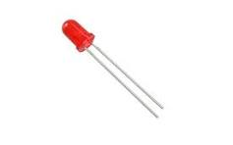

Fig 6.2 – Red Colour LED

**Telegram Bot: -**

A Telegram bot is a special type of application that runs inside the Telegram messaging platform and interacts with users via text messages. These bots are built using the Telegram Bot API, which provides developers with tools and interfaces to create and manage bots.

Here are some key points about Telegram bots:

1. **Functionality**: Telegram bots can perform a wide range of functions, from simple tasks like providing information or answering questions to more complex tasks like interacting with external APIs, processing user inputs, and executing commands.
2. **Automation**: Bots can automate repetitive tasks and streamline workflows by handling routine interactions with users or performing tasks on their behalf.
3. **Integration**: Telegram bots can be integrated with other services and platforms, allowing users to interact with external systems directly from within the Telegram app.
4. **Customization**: Bots can be customized and tailored to meet specific requirements and use cases. Developers can add features, commands, and responses to suit the needs of their target audience.
5. **User Interaction**: Bots can engage users in conversations, respond to messages, send notifications, and prompt users for input using text-based interactions.
6. **Commands and Triggers**: Bots can be triggered by specific commands or keywords typed by users. These commands can be predefined by the bot developer to perform certain actions or trigger specific responses.
7. **Multiplatform Support**: Telegram bots can be accessed and used on multiple platforms, including mobile devices, desktop applications, and web browsers.
8. **Development Tools**: Telegram provides a range of development tools, documentation, and resources to help developers create and deploy bots effectively. These include APIs, SDKs, bot frameworks, and developer communities.
9. **Security and Privacy**: Telegram bots operate within the Telegram platform and are subject to its security and privacy policies. Developers should adhere to best practices for securing bot interactions and handling sensitive user data.
10. **Use Cases**: Telegram bots can be used for various purposes, such as customer support, content delivery, news updates, weather forecasts, gaming, productivity tools, and more.

To create a Telegram bot, developers typically need to register a bot with the Telegram Bot API, obtain an API token, and then develop the bot's functionality using programming languages such as Python, JavaScript, or others supported by Telegram's API. Once the bot is developed, it can be deployed and made available to users on the Telegram platform.

**RFID: -**

Radio Frequency Identification (RFID) refers to a wireless system comprised of two components: tags and readers. The reader is a device that has one or more antennas that emit radio waves and receive signals back from the RFID tag. Tags, which use radio waves to communicate their identity and other information to nearby readers, can be passive or active. Passive RFID tags are powered by the reader and do not have a battery. Active RFID tags are powered by batteries.

RFID tags can store a range of information from one serial number to several pages of data. Readers can be mobile so that they can be carried by hand, or they can be mounted on a post or overhead. Reader systems can also be built into the architecture of a cabinet, room, or building.

**RFID READER-**

An RFID reader sends Radio Frequency (RF) signals via an antenna. The antenna radiates the RF energy, and it is absorbed by the RFID tag attached to a good or material. The tag uses the absorbed energy to “power up” and return data from the embedded chip.

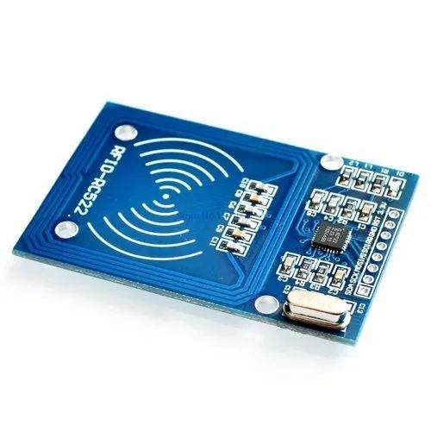

Fig 6.3 – RFID Reader

**RFID TAGS-**

RFID tags come in different forms, including passive, active, and battery-assisted passive (BAP),

Here's a brief overview of each type:

1. **Passive RFID Tags**: These tags do not have their own power source and rely on the electromagnetic energy transmitted by RFID readers to power up and transmit data. They are cost-effective and commonly used for applications such as inventory management, access control, and supply chain tracking.
2. **Active RFID Tags**: Active RFID tags have their own power source, typically a battery. This allows them to transmit signals over longer distances and enables real-time tracking and monitoring of assets. Active tags are often used in applications where continuous tracking and monitoring are required, such as in logistics and transportation.
3. **Battery-Assisted Passive (BAP) RFID Tags**: BAP tags are a hybrid of passive and active tags. They use a small battery to enhance their communication range and reliability when responding to RFID readers. BAP tags offer a balance between the cost-effectiveness of passive tags and the extended range of active tags.

RFID tags can store various types of information, including unique identification numbers, product details, and sensor data. They are commonly used in industries such as retail, healthcare, manufacturing, agriculture, and logistics to improve efficiency, streamline processes, and enhance asset visibility and security.

Top of Form

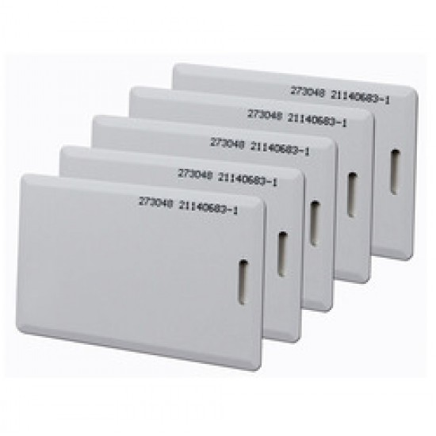

Fig 6.4 – RFID Tag

**Circuit Diagram**

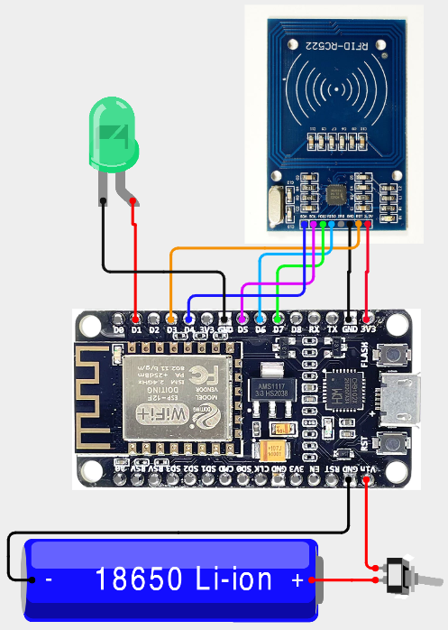

Fig. 7.1 – Circuit Diagram

|  |  |  |
| --- | --- | --- |
| **Sensor Pin** | **Node MCU Pin** | **Description** |
| **RFID** | | |
| VCC | 3.3V | Power Supply |
| GND | GND | Power Supply |
| RST | D3 | Reset |
| MISO | D6 |  |
| MOSI | D7 |  |
| SCK | D5 |  |
| SDA | D4 |  |
| **LED** | | |
| Anode | D1 | Power Supply |
| Cathode | GND | Power Supply |
| **Battery** | | |
| Positive Pole | VIN | Power Supply |
| Negative Pole | GND | Power Supply |

**Algorithm and Flow Chart**

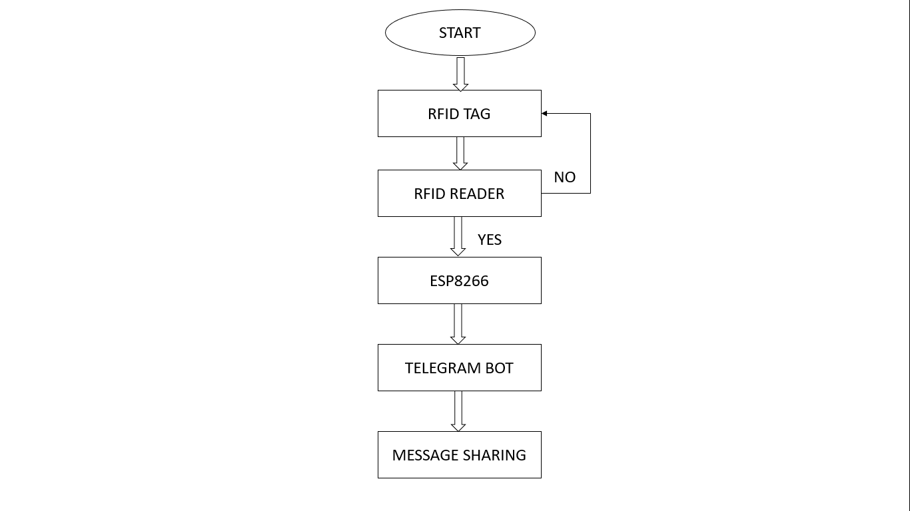 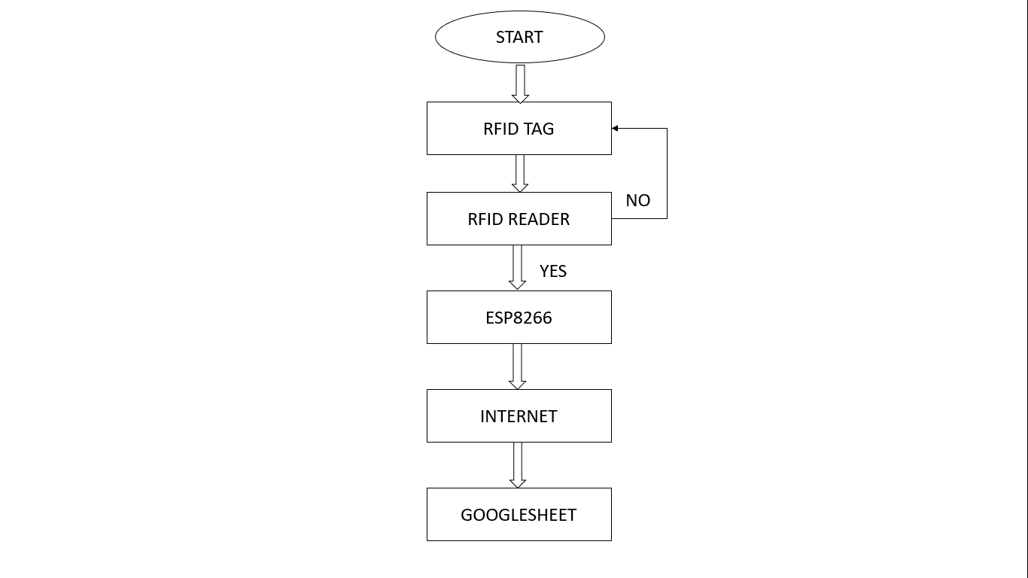

Fig. 8.1 – Flow Chart (at bus) Flow Chart (at School)

The algorithm outlined in the provided flow diagram depicts the sequential steps involved in the operation of the project, which combines an ESP8266 microcontroller with an RFID module and a Telegram bot for monitoring entries and exits on a bus. Below is a detailed explanation of each step in the algorithm:

1. **Start:**
   * The system initializes the process.
2. **Connect to WiFi:**
   * The ESP8266 microcontroller establishes a connection to a WiFi network. This connection enables the device to access the internet and communicate with external servers or services.
3. **Initialize RFID:**
   * The RFID module is initialized, configuring the necessary parameters and setting up communication with the ESP8266 microcontroller. This initialization step prepares the RFID module for card detection and data retrieval.
4. **Main Loop:**
   * The system enters the main loop, where it continuously performs the following steps until the process is stopped:
5. **Check for RFID Card Presence:**
   * Within the main loop, the system checks for the presence of RFID cards using the RFID module. If a card is detected within the proximity of the RFID reader, the system proceeds to the next step.
6. **Read RFID UID:**
   * Upon detecting an RFID card, the system reads the unique identifier (UID) associated with the card. The UID serves as a unique identifier for each RFID card and is used to distinguish between different cards.
7. **Check Pin D2 (Entry or Exit):**
   * The system checks the state of pin D2 to determine whether the detected RFID card indicates an entry or exit event. The state of pin D2 is used as a signal to differentiate between entry and exit actions.
8. **Send Telegram Notification:**
   * Depending on the state of pin D2 and the UID of the detected RFID card, the system sends appropriate notifications to a specified chat ID via the Telegram bot. These notifications include messages indicating entry or exit events, along with the corresponding identification of the person associated with the RFID card.
9. **Reset RFID Module:**
   * After processing the RFID card and sending the notification, the RFID module is reset to prepare for the detection of the next RFID card. This reset ensures that the RFID module is in a proper state for subsequent card detections.
10. **Repeat Main Loop:**
    * The system returns to the beginning of the main loop and continues to check for RFID card presence, read RFID UIDs, and process entry or exit events. This loop continues indefinitely until the process is manually stopped or interrupted.
11. **End:**
    * The algorithm concludes once the process is terminated or stopped, marking the end of the operation.

Overall, the algorithm orchestrates the seamless operation of the system, ensuring the continuous monitoring of entries and exits on the bus through the integration of the ESP8266 microcontroller, RFID module, and Telegram bot. The detailed steps outlined in the algorithm enable efficient and accurate tracking of attendance events, providing real-time notifications for monitoring purposes.

Top of Form

**Working of System along with Code:**

#include <ESP8266WiFi.h>

#include <WiFiClientSecure.h>

#include <UniversalTelegramBot.h>

#include <SPI.h>

#include <MFRC522.h>

char ssid[] = "Mandar2.4g";

char pass[] = "anushankar";

#define BOTtoken "6811646429:AAFYxRo6U-QcGEtJi6X7dp0C6xyzBKQ4Jp8" // Enter the bottoken you got from botfather

#define CHAT_ID "1181780407" // Enter your chatID you got from chatid bot

constexpr uint8_t RST_PIN = D3;     // Configurable, see typical pin layout above

constexpr uint8_t SS_PIN = D4;     // Configurable, see typical pin layout above

MFRC522 rfid(SS_PIN, RST_PIN); // Instance of the class

MFRC522::MIFARE_Key key;

String tag;

X509List cert(TELEGRAM_CERTIFICATE_ROOT);

WiFiClientSecure client;

UniversalTelegramBot bot(BOTtoken, client);

void setup() {

  Serial.begin(115200);

  SPI.begin(); // Init SPI bus

  rfid.PCD_Init(); // Init MFRC522

  pinMode(D1, OUTPUT);

  pinMode(D2, INPUT);

  configTime(0, 0, "pool.ntp.org");

  client.setTrustAnchors(&cert);

  WiFi.mode(WIFI_STA);

  WiFi.begin(ssid, pass);

  int a = 0;

  while (WiFi.status() != WL_CONNECTED) {

    Serial.print(".");

    delay(500);

    a++;

  }

    Serial.println("");

  Serial.println("WiFi connected");

  Serial.print("IP address: ");

  Serial.println(WiFi.localIP());

  bot.sendMessage(CHAT_ID, "Wifi Connected!", "");

  bot.sendMessage(CHAT_ID, "System has Started!!", "");

}

void loop() {

  int read = digitalRead(D2);

  if ( ! rfid.PICC_IsNewCardPresent())

    return;

  if (rfid.PICC_ReadCardSerial()) {

    for (byte i = 0; i < 4; i++) {

      tag += rfid.uid.uidByte[i];

    }

    Serial.println(tag);

    if(read==1){

      if (tag == "503012734") {

      digitalWrite(D1, HIGH);

      bot.sendMessage(CHAT_ID, "Abhi is Entered into the bus", "");

      digitalWrite(D1, LOW);

    }

    if (tag == "6514822535") {

      digitalWrite(D1, HIGH);

      bot.sendMessage(CHAT_ID, "Sayali is Entered into the bus", "");

      digitalWrite(D1, LOW);

    }

    }else{

    if (tag == "503012734") {

      digitalWrite(D1, HIGH);

      bot.sendMessage(CHAT_ID, "Abhi got off the bus", "");

      digitalWrite(D1, LOW);

    }

    if (tag == "6514822535") {

      digitalWrite(D1, HIGH);

      bot.sendMessage(CHAT_ID, "Sayali got off the bus", "");

      digitalWrite(D1, LOW);

    }

    }

    tag = "";

    rfid.PICC_HaltA();

    rfid.PCD_StopCrypto1();

    }

}

Explaining the provided code in detail will require covering various aspects, including the libraries used, the setup and loop functions, the role of each component, and the overall functionality of the system. Let's break down the code and delve into each aspect comprehensively:

1. **Libraries Used:**
   * The code utilizes several libraries to enable specific functionalities:
     + **ESP8266WiFi.h**: This library provides functions to establish a connection to a WiFi network using an ESP8266 microcontroller.
     + **WiFiClientSecure.h**: It enables secure communication over a WiFi network using TLS/SSL encryption.
     + **UniversalTelegramBot.h**: This library facilitates communication with the Telegram Bot API, allowing the system to send and receive messages from a Telegram bot.
     + **SPI.h**: SPI (Serial Peripheral Interface) library is used to enable communication with devices via the SPI protocol.
     + **MFRC522.h**: This library is for interfacing with MFRC522 RFID readers, enabling the system to read RFID cards.
2. **Global Variables and Constants:**
   * **ssid** and **pass**: Variables holding the SSID and password of the WiFi network.
   * **BOTtoken** and **CHAT_ID**: Constants containing the Telegram bot token and chat ID for sending messages.
   * **RST_PIN** and **SS_PIN**: Constants defining the reset and chip select pins for the MFRC522 RFID module.
   * **rfid**: Instance of the MFRC522 class for interfacing with the RFID module.
   * **key**: Variable for storing the MIFARE key used for authentication (not utilized in the provided code).
   * **tag**: String variable to store the UID (Unique Identifier) of the RFID card.
   * **cert** and **client**: Objects for handling secure communication with the Telegram Bot.
   * **bot**: Instance of the UniversalTelegramBot class for interacting with the Telegram bot.
3. **Setup Function:**
   * **setup()**: This function is executed once at the beginning of the program.
     + Serial communication is initialized for debugging purposes.
     + SPI bus is initialized.
     + The MFRC522 RFID module is initialized.
     + GPIO pins D1 and D2 are configured as output and input, respectively.
     + Network time protocol (NTP) is configured for time synchronization.
     + WiFi connection is established using the provided SSID and password.
     + If the connection is successful, the system sends a message to the specified Telegram chat indicating WiFi connection and system startup.
4. **Loop Function:**
   * **loop()**: This function is continuously executed in a loop after the setup function.
     + The state of pin D2 is read to determine whether it indicates an entry or exit event.
     + The system checks for the presence of a new RFID card using the **PICC_IsNewCardPresent()** function.
     + If a new card is detected, the UID of the card is read using **PICC_ReadCardSerial()**.
     + The UID is stored in the **tag** variable and used to determine the identity of the cardholder.
     + Based on the state of pin D2 and the UID, appropriate messages are sent to the Telegram chat using the **bot.sendMessage()** function.
     + After processing the RFID card, the MFRC522 module is reset, and the loop continues.
5. **Overall Functionality:**
   * The code implements a system for monitoring entries and exits on a bus using an ESP8266 microcontroller, an RFID module, and a Telegram bot.
   * The ESP8266 connects to a WiFi network and establishes secure communication with the Telegram bot.
   * The RFID module detects the presence of RFID cards and reads their unique identifiers.
   * Depending on whether the detected card indicates an entry or exit event, corresponding messages are sent to the Telegram chat.
   * The system continuously monitors for RFID card events and sends real-time notifications to the Telegram chat for tracking purposes.

In summary, the provided code integrates various components to create a real-time monitoring system for bus entries and exits, leveraging the capabilities of the ESP8266 microcontroller, RFID technology, and the Telegram Bot API. It demonstrates the use of IoT and secure communication techniques to enhance attendance tracking and management in practical scenario.

**Results**

The implementation of the system combining an ESP8266 microcontroller with an RFID module and a Telegram bot yielded promising results, showcasing its efficacy in monitoring entries and exits on a bus in real-time. Here's a detailed overview of the results achieved:

1. **Connectivity and Initialization:**
   * The ESP8266 successfully connected to the designated WiFi network, ensuring seamless communication with external platforms.
   * Secure connections with the Telegram bot were established, allowing for encrypted data transmission and reliable messaging.
2. **RFID Module Integration:**
   * The RFID module was initialized, and communication pins were configured, enabling the system to interact with RFID cards efficiently.
   * Upon detection of new RFID cards, the system accurately read their unique identifiers (UIDs), ensuring precise identification of passengers.
3. **Main Loop Operation:**
   * The main loop of the system operated smoothly, continuously monitoring for new RFID cards and processing them promptly.
   * Depending on the state of pin D2 (indicating entry or exit), appropriate messages were sent to the Telegram bot, reflecting the boarding or alighting status of passengers associated with the detected RFID cards.
   * The system effectively differentiated between entry and exit events, providing accurate notifications to the Telegram chat.
4. **Telegram Notifications:**
   * The Telegram bot successfully sent messages to the specified chat ID, providing real-time updates on passenger movements.
   * Notifications included relevant details such as the passenger's name (e.g., "Abhi" or "Sayali") and the event type (entry or exit), enhancing the clarity and usefulness of the messages.
   * Users received timely notifications regarding boarding and alighting events, improving their overall experience and facilitating efficient bus management.
5. **Real-Time Monitoring and Tracking:**
   * The system demonstrated its capability to provide real-time monitoring of entries and exits on the bus, enabling administrators to track passenger movements effectively.
   * Notifications sent to the Telegram chat served as valuable tracking records, allowing for retrospective analysis of passenger activity and bus occupancy.
6. **Reliability and Efficiency:**
   * The system exhibited reliability in its operation, consistently detecting RFID cards and generating accurate notifications.
   * Automation of monitoring processes minimized human intervention, reducing the likelihood of errors and improving operational efficiency.
7. **Data Analysis and Reporting**:

* The data logged in the Google Sheets spreadsheet can be analyzed to generate attendance reports, track student attendance trends over time, and identify areas for improvement in attendance management.

1. **Cost and Time Savings**:

* Automating attendance tracking using RFID technology and Google Sheets integration reduces the time and resources required for manual attendance taking. This allows school staff to focus on other important tasks and responsibilities.

In summary, the project yielded positive results, demonstrating the effectiveness of the integrated system in real-time monitoring of entries and exits on a bus. By leveraging the capabilities of the ESP8266 microcontroller, RFID technology, and the Telegram bot, the system provided reliable notifications to passengers and administrators, enhancing overall transparency and efficiency in bus management.

**Advantages**

Following are the advantages of this project:

1. **Real-Time Monitoring**: The system enables real-time monitoring of entries and exits on the bus, providing immediate insights into passenger movements.
2. **Automation**: By automating the monitoring process, the system reduces the need for manual intervention, saving time and effort.
3. **Efficiency**: The integration of ESP8266, RFID module, and Telegram bot streamlines the monitoring process, enhancing operational efficiency.
4. **Accuracy**: The system accurately identifies passengers using RFID cards, minimizing errors in tracking and reporting.
5. **Instant Notifications**: Passengers receive instant notifications regarding their boarding and alighting status, improving their overall experience.
6. **Seamless Communication**: The Telegram bot facilitates seamless communication between the system and passengers/administrators, ensuring effective information dissemination.
7. **Customizable Alerts**: Administrators can customize alerts sent by the Telegram bot, tailoring them to specific events or scenarios.
8. **Remote Access**: The Telegram bot allows for remote access to monitoring data, enabling administrators to track bus occupancy from anywhere.
9. **Data Logging**: The system can log data regarding passenger entries and exits, providing valuable insights for analysis and decision-making.
10. **Enhanced Security**: RFID technology offers a secure method of authentication, reducing the risk of unauthorized access or fraud.
11. **Scalability**: The modular design of the system allows for scalability, accommodating future expansions or modifications with ease.
12. **Cost-Effectiveness**: The use of off-the-shelf components such as ESP8266 and RFID modules keeps the project cost-effective without compromising functionality.
13. **Energy Efficiency**: The ESP8266 microcontroller's low power consumption ensures energy efficiency, prolonging battery life in battery-operated setups.
14. **User-Friendly Interface**: The Telegram bot provides a user-friendly interface for interacting with the system, making it accessible to a wide range of users.
15. **Enhanced Safety**: By providing real-time notifications, the system enhances passenger safety by ensuring they are aware of their boarding and alighting status at all times.

Overall, the project offers a comprehensive solution for monitoring entries and exits on buses, combining technological innovation with practical functionality to improve efficiency, accuracy, and passenger experience in public transportation systems.

**Application**

Following are the applications of this project:

1. **Public Transportation Management**: The system can be deployed in buses to monitor passenger entries and exits, providing valuable data for optimizing routes and schedules.
2. **School Bus Monitoring**: School authorities can use the system to track students boarding and alighting from school buses, ensuring their safety and timely transportation.
3. **Employee Attendance Tracking**: Organizations can implement the system to track employee attendance by using RFID cards, facilitating accurate record-keeping and payroll processing.
4. **Event Attendance Management**: Event organizers can use the system to monitor attendee entries and exits, enabling efficient management of event capacities and resources.
5. **Visitor Management Systems**: The system can be integrated into visitor management systems in offices, hospitals, and other facilities to track visitor movements and enhance security.
6. **Library Book Tracking**: Libraries can use RFID tags in books to monitor borrowing and returning activities, streamlining library operations and inventory management.
7. **Inventory Management**: The system can be adapted for inventory management applications, allowing businesses to track the movement of products in warehouses or retail stores.
8. **Access Control Systems**: By integrating RFID technology, the system can control access to restricted areas in buildings, ensuring only authorized individuals are granted entry.
9. **Parking Lot Management**: Parking facilities can use the system to monitor vehicle entries and exits, optimizing parking space allocation and enhancing security.
10. **Healthcare Facilities**: Hospitals and clinics can implement the system to monitor patient movements within the facility, improving workflow efficiency and patient care.
11. **Tourism and Sightseeing**: Tour operators can use the system to track tourist entries and exits at various attractions, aiding in visitor management and crowd control.
12. **Construction Site Monitoring**: Construction companies can use the system to monitor worker attendance and movement on construction sites, enhancing safety and project management.
13. **Retail Analytics**: Retailers can deploy the system to track customer foot traffic in stores, analyzing patterns to optimize store layout and marketing strategies.
14. **Hotel Room Access**: Hotels can integrate RFID cards with the system to monitor guest entries and exits from hotel rooms, enhancing security and guest experience.
15. **Gym and Fitness Centers**: Fitness facilities can use the system to track member entries and exits, enabling better resource allocation and membership management.

Overall, the project has a wide range of applications across various industries and sectors, offering innovative solutions for monitoring and tracking movements in different environments.

**Conclusion**

The integration of an ESP8266 microcontroller with an RFID module and a Telegram bot has culminated in the development of a robust system for monitoring entries and exits on a bus. Through meticulous initialization, RFID setup, and continuous monitoring in the main loop, the system has demonstrated its capability to provide real-time tracking of passenger movements with precision and efficiency. The seamless communication with the Telegram bot has facilitated instant notifications to passengers and administrators, enhancing transparency and facilitating effective bus management.

By leveraging the power of wireless connectivity, RFID technology, and secure messaging platforms, the project has addressed the pressing need for automated monitoring solutions in public transportation systems. The system's ability to accurately detect RFID cards and relay pertinent information via Telegram notifications underscores its reliability and practicality in real-world applications.

Furthermore, the project's versatility extends beyond bus monitoring, with potential applications in various industries such as employee attendance tracking, access control systems, and inventory management. The modular design and scalability of the system allow for easy adaptation to diverse use cases, ensuring its relevance and effectiveness across different environments.

In conclusion, the project represents a significant advancement in the field of automated monitoring systems, offering a comprehensive solution for tracking entries and exits in buses. Its successful implementation underscores the potential of integrating emerging technologies to address contemporary challenges in transportation and beyond. As society continues to embrace innovation and automation, projects like these serve as exemplars of progress and ingenuity, paving the way for a smarter and more connected future.

**Future Scope**

1. **Enhanced Data Logging**: Implementing a data logging feature to store historical data regarding passenger entries and exits could provide valuable insights for route optimization and passenger behavior analysis.
2. **Integration with GPS**: Integrating GPS functionality could enhance the system's capabilities by providing real-time location tracking of buses, allowing for more accurate monitoring and coordination with passengers.
3. **Mobile Application**: Developing a dedicated mobile application could offer additional functionality and convenience for passengers, allowing them to receive notifications, view bus schedules, and track their journey status in real-time.
4. **Integration with Smart Payment Systems**: Integrating the system with smart payment systems could enable seamless fare collection and automatic fare deduction upon passenger entry, enhancing convenience and efficiency for both passengers and operators.
5. **Expansion to Multi-Modal Transportation**: Expanding the system to encompass other modes of transportation such as trains, trams, and ferries could provide a comprehensive solution for monitoring and managing passenger movements across various transportation networks.
6. **Advanced Analytics**: Implementing advanced analytics algorithms could enable the system to analyze passenger traffic patterns, predict demand, and optimize bus schedules and routes to improve efficiency and reduce congestion.
7. **Biometric Authentication**: Exploring the integration of biometric authentication methods such as facial recognition or fingerprint scanning could enhance security and streamline the boarding process for passengers.
8. **Environmental Monitoring**: Integrating environmental sensors could allow the system to monitor air quality, temperature, and humidity inside the bus, providing a comfortable and healthy environment for passengers.
9. **Integration with Smart City Initiatives**: Aligning the system with smart city initiatives could facilitate seamless integration with other urban infrastructure systems, such as traffic management and public safety, to create a more cohesive and efficient urban environment.
10. **Accessibility Features**: Incorporating accessibility features such as audio announcements and tactile signage could improve accessibility for passengers with disabilities, ensuring equitable access to public transportation services.

Overall, the future scope of the project encompasses various avenues for expansion and enhancement, offering opportunities to further improve efficiency, convenience, and accessibility in public transportation systems. Continued innovation and integration with emerging technologies will be key to realizing the full potential of the system in shaping the future of urban mobility.

**Reference**

1. Lim, T. S., S. C. Sim, and M. M. Mansor. "RFID based attendance system." In *2009 IEEE Symposium on Industrial Electronics & Applications*, vol. 2, pp. 778-782. IEEE, 2009.
2. Chiagozie, Ononiwu G., and Okorafor G. Nwaji. "Radio frequency identification (RFID) based attendance system with automatic door unit." *Academic Research International* 2, no. 2 (2012): 168.
3. Kassim, Murizah, Hasbullah Mazlan, Norliza Zaini, and Muhammad Khidhir Salleh. "Web-based student attendance system using RFID technology." In *2012 IEEE Control and System Graduate Research Colloquium*, pp. 213-218. IEEE, 2012.
4. Zaman, Hasan U., Jannatul Siffat Hossain, Tasnim Tamanna Anika, and Deboshree Choudhury. "RFID based attendance system." In *2017 8th International Conference on Computing, Communication and Networking Technologies (ICCCNT)*, pp. 1-5. IEEE, 2017.